**Jackson School District**

**AP Computer Science**

**Summer Assignment**

Congratulations on being selected for AP Computer Science! In this course you will continue to learn fundamentals of computer science with focus on Object Oriented Programming Concepts. Major topics to be discussed this year are: classes, interaction of different classes to solve problems, inheritance, 2D arrays, ArrayLists, polymorphism, sorting and searching algorithms and recursion.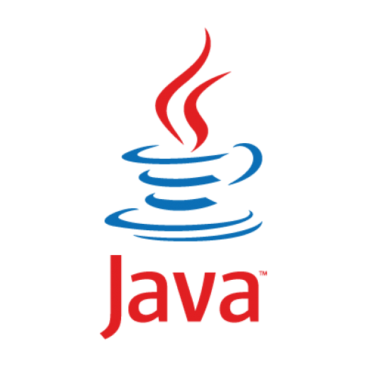

This course will prepare you for further study of computer science, and is the first step in preparing for a career in software engineering, information management or any other field of study you wish to pursue. Computer Science has a wide range of applications in biology, mathematics, physics, finance, history, social science and can be combined with any field of study. More than anything else, this course will allow you to develop your logical reasoning and problem solving ability.

This course is going to be very quick-paced, in the sense that it builds on your ability to understand and apply logical structures learned in introduction to computer science**. My objective for this summer assignment is not to overwhelm you with work, but to make sure we start the year ready to move forward from where we left off in the Intro to Java class.

This assignment will be collected/shared within the first week of school.

*\*\*If you did not take the Intro to Java course, I have an extra* [*recommended assignment*](https://docs.google.com/document/d/e/2PACX-1vSW1gCyB3OkAQnA8ipSZ8NvqIIc7GWuLgH2gj8BEoWCbEyHr8I-OuAgSoB5ehY2kEPOCliAESsG7Coa/pub)*. This is also good if you just want to brush up on the topics we covered in the Intro course.*

**Resources:**

* Blue Pelican Java: A free online book. Google Blue Pelican java pdf.
* Eclipse: We use [Eclipse](https://eclipse.org/) as our IDE in school, but there are a variety of other IDE’s you can use that can be downloaded or done in the browser. Please see additional [document](https://docs.google.com/document/d/e/2PACX-1vT_WPrxZCnGPg6pJP8bn5pSOG_E85wEuXAca2FnxBrkejXQHtXzfneEHFdDw0ZMrdnSTs1bbeF0Dbus/pub) on Setting up a Java Environment. You can also use repl.it
* Helpful Java videos: [New Boston Java](https://www.youtube.com/watch?v=Hl-zzrqQoSE&list=PLFE2CE09D83EE3E28&index=1)

**Programs: (Graded for all students)**

The following programs can be done on paper *or* on the computer (preferred).

1. Write a program that will allow the user to enter two points and will output the distance between the two points using the distance formula.
2. Write a program that will generate a random month and year from 1950 to 2017 inclusive. A sample output might include the following: 12/1978 or 7/2017.
3. Write a program that asks the user to enter a sentence. Count how many vowels appear in the sentence and how many non-vowels. Non-vowels include spaces and punctuation.
4. Write a program that outputs the roots of a quadratic equation. The user should enter in a, b and c. If the roots are imaginary, simply output, no real roots.

If you have any questions, please feel free to email

JMHS: Mrs. Kirschenbaum-Perry [djperry@jacksonsd.org](mailto:djperry@jacksonsd.org)

JLHS: Mr. Perry [cperry@jacksonsd.org](mailto:cperry@jacksonsd.org)

Good luck and have a great summer.